

MEGACITIES PARTNERSHIP

BenMAP-CE

Overview and Information Organizer

May 2021

Table of Contents

1. Introduction to BenMAP-CE 2

2. Example Megacities Partnership analyses using BenMAP-CE 3

3. How to Organize Information Needed for a BenMAP-CE Analysis 4

a. Policy question/Purpose of analysis 4

b. Geographic scope/resolution 4

c. Pollutant(s) of interest 4

d. Baseline and control air quality scenarios 4

e. Air quality data 5

f. Population 5

g. Baseline health incidence data 5

h. Health endpoints to be analyzed 5

i. Valuation 5

j. Communication of results (e.g. maps, tables) 5

4. Datasets necessary for a BenMAP-CE setup 8

5. BenMAP-CE resources 12

References 12

1. Introduction to BenMAP-CE

The Environmental Benefits Mapping and Analysis Program – Community Edition (BenMAP-CE) is an air quality benefits analysis software that estimates the number and value of mortality and morbidity associated with changes in air quality (U.S. EPA). BenMAP-CE allows users to upload city, regional, or country specific air quality, demographic, health, and economic data for health impact analyses. The program can run at various spatial scales and provides users with health burden estimates at different snapshots in time.

Analysts and policymakers use BenMAP-CE to understand the total health burden of air pollution facing a specific location as well as the benefits of rolling back air pollution levels by a specified amount. BenMAP-CE is a flexible tool for conducting policy scenario analysis as it has built-in functionality to “roll-back” measured air pollution concentrations—by percentage, a specific increment, or to an air quality standard—across the area of interest (U.S. EPA).

Benefits calculations rely on four main datasets, presented in **Figure 1** below: 1) air quality change, 2) population data, 3) health incidence data, and 4) epidemiological health impact functions. BenMAP-CE links these data spatially and calculates the health impact for exposed populations, given specific incidence rates and air quality exposure. An additional valuation dataset is necessary to calculate the monetary value of air pollution-related health benefits.

**FIGURE 1. INPUTS USED WITH BENMAP-CE TO ESTIMATE HEALTH IMPACT OF AQ CHANGE**

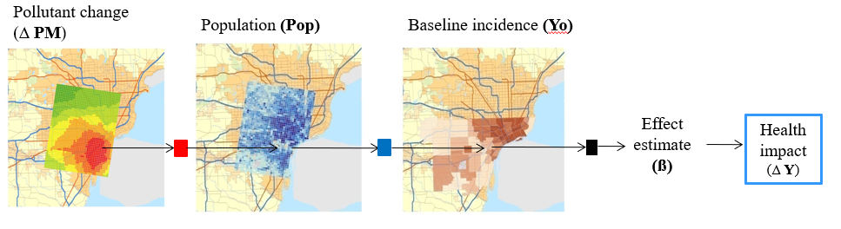

Steps to calculating health impacts in BenMAP-CE. Air quality, population, and incidence data are spatially related to estimate a specific health endpoint in an area of interest.

BenMAP-CE is organized around location-specific “setups” that include the datasets described above for a city, region, or country. One of the capacity building objectives in previous Megacities Partnerships (e.g. Accra, Ghana; Addis Ababa, Ethiopia) has been to gather disparate data sources from local partners or globally available datasets, develop a working Megacity setup in BenMAP-CE, and build technical capacity in using the program for future policy scenario analyses. It is a goal within the Megacities Partnership for local partners to continue updating and adding data to their BenMAP-CE setup for more refined and detailed analyses over time.

Previous Megacities Partnerships used BenMAP-CE to perform baseline health assessments, which quantify the total health impact of air pollution in the city for a specified baseline year. The baseline health burden results were incorporated into the air quality management plan (AQMP) as quantitative evidence supporting action on improving air quality and as a starting point for policy recommendations. Subsequently, BenMAP-CE can be used to estimate the benefits of air pollution control policies laid out in the AQMP or estimate past or future impacts.

1. Example Megacities Partnership analyses using BenMAP-CE:

* Santiago, Chile: Retrospective benefits analysis of air pollution. **Figure 2** below shows results of retrospective analysis using three different health impact functions.

**Figure 2. Annual Premature Deaths Avoided, 1995-2020**

Bar graph showing the number of annual premature deaths avoided from 1995 to 2020 in five year increments. Results from three different health impact functions (Krewski et al., Burnett and Laden et al.) are shown, all of which display an upward trend.


* + The full retrospective benefit-cost analysis can be found at:

<https://www.epa.gov/sites/production/files/2019-02/documents/santiago_megacities_partnership_final_report.pdf>

* Accra, Ghana: Baseline health burden; projected baseline health burden for one future year under a business-as-usual scenario; health benefits of sector-specific air pollution reductions in future year in accordance with policies outlined in AQMP
  + The full AQMP can be found at EPA Ghana’s website at: <http://www.epa.gov.gh/epa/sites/default/files/downloads/publications/Greater%20Accra%20Region%20Air%20%20Quality%20Management%20Plan%202%20Oct%20%202018%20updated.pdf>
* Addis Ababa, Ethiopia: Baseline health burden, projected baseline health burden for two future years under a business-as-usual scenario

1. How to Organize Information Needed for a BenMAP-CE Analysis

The information below (a - j) provides a convenient way to consider the purpose for potential BenMAP-CE analyses as well as a template for understanding and organizing the information required.

1. Policy question/Purpose of analysis:

[A brief statement covering the objectives of the analysis]

1. Geographic scope/resolution:

[What is your area of interest? What resolution of results will be needed to answer your question? E.g. Which district in Santiago experiences the highest health burden from current air pollution levels?]

c) Pollutant(s) of interest:

[e.g., PM2.5 or O3]

d) Baseline and control air quality scenarios:

[For each analysis you want to conduct, how will you define the baseline (“business as usual”) air quality scenario, and how will you define the control air quality scenario?]

e) Air quality data:

[What sources of air quality data will you use for your analysis? Is it monitor or model data? What is the temporal resolution of the data? If model data, what is the geographic resolution?]

f) Population:

[What sources of population data will you use? E.g. Federal government census or municipal government data? How are the data stratified (e.g., by age, gender, etc.)? What year?]

g) Baseline health incidence data:

[What sources of baseline incidence data will you use? E.g. Publicly available data from the Global Burden of Disease study or locally collected data from hospital records? How are the data stratified (e.g., by age, gender, etc.)? What year?]

h) Health endpoints to be analyzed:

[What health endpoints are of interest (e.g., annual all-cause mortality, daily respiratory hospital admissions)? What health impact functions will be used to evaluate inputs? Where did the health impact function study take place?]

1. Valuation:

[Are you planning to value the health impacts? If so, what value(s) will you use? Commonly, cost of illness (COI) and willingness to pay (WTP) measures are used for morbidity and mortality endpoints, respectively.]

1. Communication of results (e.g. maps, tables):

[What type of outputs do you need? How would you like to present your results? An example map and table are provided below.]

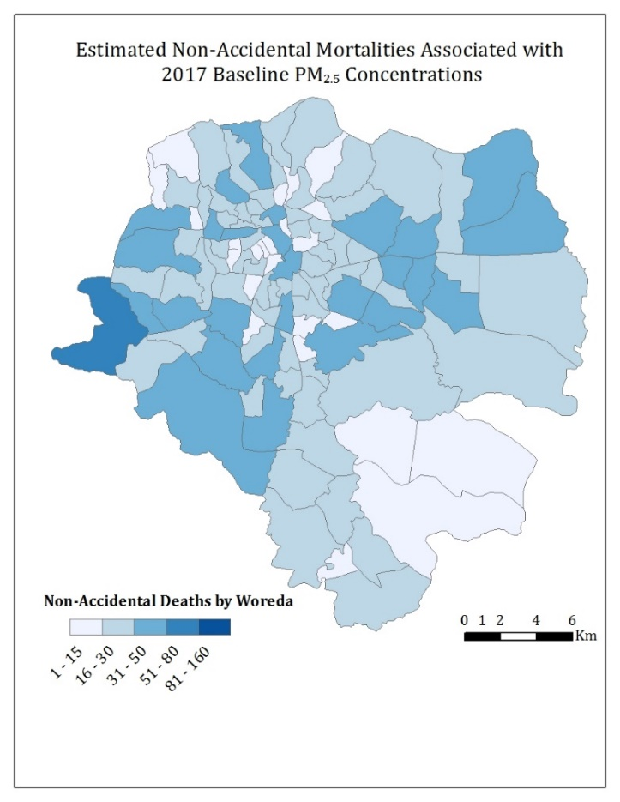**Figure 3: Example results map**

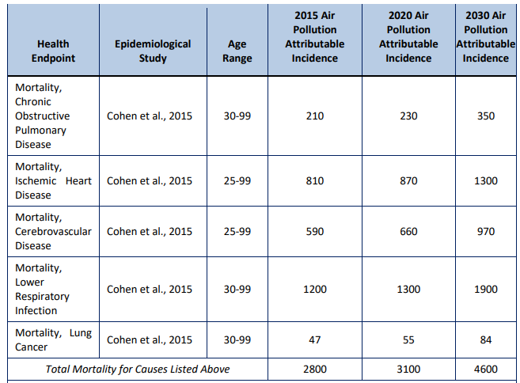**Table 1. Example Results Table**

1. Datasets necessary for a BenMAP-CE setup:

The series of 6 tables presented below will help you organize input datasets, document data sources, and prepare details necessary for files to be ready for use in BenMAP-CE. The first line of each table provides an example of the type of information needed in each column, followed by several blank rows to allow for your input. These tables should contain the full set of files that you will need for your analysis. They will also help you document and share your work with others.

**Table 2. Grid Definitions**

|  |  |  |  |  |  |  |
| --- | --- | --- | --- | --- | --- | --- |
| Grid Definition Name | Geographic Scale | Datasets associated with grid definition (if applicable) | File Type | Data Source | Weblink or file path on computer | Processed for BenMAP? |
| *U.S. County* | *County* | *Incidence, population* | *Shapefile (.shp)* | *Census Bureau* | [*TIGER*](https://catalog.data.gov/dataset/tiger-line-shapefile-2017-nation-u-s-current-county-and-equivalent-national-shapefile) *Line* | *No* |
|  |  |  |  |  |  |  |
|  |  |  |  |  |  |  |
|  |  |  |  |  |  |  |
|  |  |  |  |  |  |  |

**Table 3. Monitor Air Quality Data**

|  |  |  |  |  |  |  |  |  |
| --- | --- | --- | --- | --- | --- | --- | --- | --- |
| Monitor Dataset Name | Extent | Years of data available | Pollutants monitored | Frequency of measure-ments | File Type | Data Source | Weblink or file path on computer | Processed for BenMAP? |
| *City X Network* | *5 monitors covering a 3km2 area* | *2015-2018* | *PM2.5, PM10* | *Hourly* | *.csv* | *US EPA* | *C:\AQ\monitors* | *Yes* |
|  |  |  |  |  |  |  |  |  |
|  |  |  |  |  |  |  |  |  |
|  |  |  |  |  |  |  |  |  |
|  |  |  |  |  |  |  |  |  |

**Table 4. Model Air Quality Data**

|  |  |  |  |  |  |  |  |  |
| --- | --- | --- | --- | --- | --- | --- | --- | --- |
| Model Scenario | Scenario Description | Geographic scale of air quality | Baseline or Control? | Frequency of measurements | File Type | Data Source | Weblink or file path on computer | Processed for BenMAP? |
| *2020 Business as Usual* | *Projected air quality for 2020, no air quality measures* | *12 x 12 km grid* | *Baseline* | *Annual average* | *.csv* | *Air quality modeling department* | *C:\AQ\models* | *No* |
|  |  |  |  |  |  |  |  |  |
|  |  |  |  |  |  |  |  |  |
|  |  |  |  |  |  |  |  |  |
|  |  |  |  |  |  |  |  |  |

**Table 5. Population Dataset**

|  |  |  |  |  |  |  |  |  |  |
| --- | --- | --- | --- | --- | --- | --- | --- | --- | --- |
| Year | Actual or projected? | Geographic scale | Age Bins? | Gender? | Ethnicity or race? | File Type | Data Source | Weblink Or Computer file path | Processed for BenMAP? |
| *2015* | *Actual* | *County* | *10-year bins* | *Yes* | *No* | *Pdf* | *American Community Survey* | [*ACS*](https://factfinder.census.gov/faces/nav/jsf/pages/searchresults.xhtml?refresh=t) | *No* |
|  |  |  |  |  |  |  |  |  |  |
|  |  |  |  |  |  |  |  |  |  |
|  |  |  |  |  |  |  |  |  |  |
|  |  |  |  |  |  |  |  |  |  |

**Table 6. Incidence Dataset**

|  |  |  |  |  |  |  |  |  |  |  |
| --- | --- | --- | --- | --- | --- | --- | --- | --- | --- | --- |
| Health Endpoint | Year | Actual or projected? | Geographic scale | Age Bins? | Gender? | Ethnicity or race? | File Type | Data Source | Weblink or file path on computer | Processed for BenMAP? |
| *Mortality, All Cause* | *2010, 2015, 2020* | *Projected* | *National* | *All ages* | *Yes* | *No* | *.xlsx* | *IHME Global Burden of Disease* | [*GBD*](http://ghdx.healthdata.org/gbd-results-tool) | *No* |
|  |  |  |  |  |  |  |  |  |  |  |
|  |  |  |  |  |  |  |  |  |  |  |
|  |  |  |  |  |  |  |  |  |  |  |
|  |  |  |  |  |  |  |  |  |  |  |

**Table 7. Health Impact Functions**

|  |  |  |  |  |  |
| --- | --- | --- | --- | --- | --- |
| Health Endpoint | Pollutant and Air Quality Metric1 | Age Range | Incidence dataset corresponding to endpoint? | Data Source | Processed for BenMAP? |
| *Mortality, Lung Cancer* | *PM2.5, Annual average* | *30-99* | *Yes – incidence included in default US setup* | *Krewski D, Jerrett M, Burnett R, et al. 2009. Extended Follow-Up and Spatial analysis of the American Cancer Society Linking Particulate Air Pollution and Mortality. Health Effects Institute, Cambridge MA* | *Yes – included in default US setup* |
|  |  |  |  |  |  |
|  |  |  |  |  |  |
|  |  |  |  |  |  |
|  |  |  |  |  |  |

1. The Pollutant and Air Quality Metric are related across air quality input datasets, baseline incidence, and health impact function.
2. BenMAP-CE Resources

There are multiple resources available online to learn and practice using BenMAP-CE. For more information, please visit the EPA website (https://www.epa.gov/benmap).

* BenMAP-CE installer (https://www.epa.gov/benmap/benmap-downloads)
* BenMAP-CE User’s Manual and Appendices (https://www.epa.gov/benmap/benmap-ce-manual-and-appendices)
* Self-paced training materials (https://www.epa.gov/benmap/benmap-ce-training-materials)
* Country datasets (https://www.epa.gov/benmap/benmap-ce-regional-datasets)
* Visit the BenMAP-CE Discussion Forum (https://forum.benmap.org/) to get updates on BenMAP-CE related events, ask questions to other BenMAP-CE users, and receive technical support.

References

U.S. EPA. Environmental Benefits Mapping and Analysis Program - Community Edition (BenMAP-CE), <https://www.epa.gov/benmap>