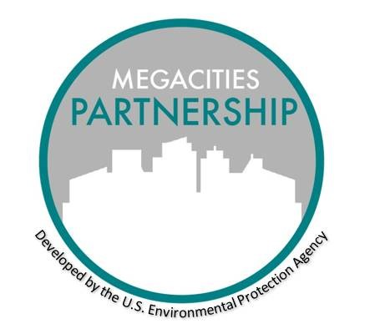

MEGACITIES PARTNERSHIP

Air Quality Management Project and Advisory Committee Structure

May 2021

OVERVIEW

A successful Partnership will require input from a range of stakeholders. Identifying roles and responsibilities within the project early can help improve an understanding of how each agency and stakeholder group may contribute to the larger AQMP development effort. Some cities may also find it advantage to convene local experts from government, academia and civil society to guide their air quality management planning efforts. This group can help obtain buy-in for the activities identified in the AQMP, as well as provide expert advice on the technical and policy components of the plan.

Objectives

* Propose and outline the main responsibilities for the Advisory Committee
* Provide role descriptions for potential committee members
* Inform the host agency of the Advisory Committee responsibilities to help identify qualified members

Project Leads

Theseare the people who are tasked with the overall execution of the project. List below their affiliated organization or agency, name, and title.

* *Agency 1* – [Fill in name and title]
* *Agency 2* – [Fill in name and title]
* *Relevant elected official* – [Fill in name and title]
* Leads could include other representatives from health bureaus, meteorological agencies etc.

Advisory Committee (potentially named Clean Air Advisory Committee)

**Purpose:** To provide the Project Leads with advice and recommendations as they develop an Air Quality Management Plan for target area.

* Final authority for the city Air Quality Management Plan rests with the [City] Government, though certain policies may depend on national level authorities (e.g., national fuel standards or vehicle import standards.)

**Commitment:** By agreeing to serve on the Advisory Committee, participant commit to attending 4-6 training events and meetings through [Fill in date]. Participants also commit to review 3-4 draft technical and policy documents that will be developed under the Megacity Partnership, including a draft Information Collection Review; a draft work plan and a draft Air Quality Management Plan.

**Benefits:** Participants will help shape the future of air quality in [City]. In addition, participating organizations will have the opportunity to engage in the many capacity building components planned under the Megacity Partnership and build strategic partnerships with other participating organizations.

**Member Organizations:** Optimally consisting of 8-10 representatives. Membership and continued participation will be determined by the project leads. Examples include:

* Health Bureau
* Transport Authority
* City Planning
* Academic Institutions
* Civil Society Organizations